Task 8

Introduction

Assumptions

2.1 Graph Model Assumptions
We assume the input is a weighted undirected graph G = (V, E, w) , where V is the set of vertices, ( E ) is the set of undirected edges, and w : E -> R ≥ 0 assigns a nonnegative weight to each edge. The number of vertices is n = |V| and the number of edges is m = |E| . This interpretation is adopted because the task statement refers to “minimum cut” without specifying a source and sink; in standard algorithmic terminology, this typically indicates the global minimum cut in an undirected weighted graph (as opposed to s-t cut in a directed network).
Citation: [1], [3].

2.2 Weight Assumptions
All edge weights are assumed to satisfy w(e) ≥ 0 . This is a common assumption for minimum-cut problems because it ensures the objective function is meaningful as a “cost” to be minimized; negative weights can lead to degenerate cases where the optimum is obtained by forcing negative edges to cross the cut, which changes the typical interpretation of a cut as a separation cost.
Citation: [3], [5].

2.3 Cut Definition Assumptions (Global Min Cut)
A cut is defined as a partition of the vertex set into two nonempty disjoint subsets S and T=V/S. The cut is denoted (S, T). We require S ≠ø and T ≠ø to avoid trivial partitions that do not separate the graph.
Citation: [3], [4].
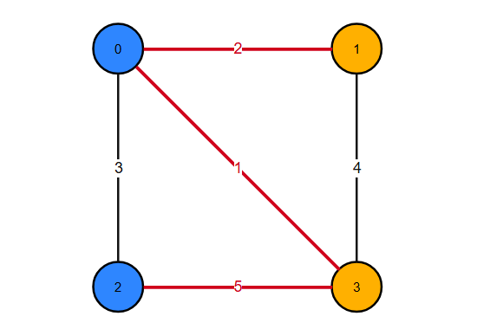
Figure 1 -Example Cut in a weighted graph
S = {0, 2} (blue) T = {1, 3} (orange)
Crossing edges: (0,1) w=2, (0,3) w=1, (2,3) w=5 ⇒ Cut weight = 8

2.4 Objective Function Assumptions (Cut Weight)
The weight (cost) of a cut (S,T) is the sum of weights of all edges with one endpoint in S and the other endpoint in T:
$$W\left(S,T\right)=\sum_{\{u,v\}∈E, u∈S, v∈T}{w\left(u,v\right)}$$
The global minimum cut problem is to find (S, T) that minimizes W(S, T) .
Citation:[3], [4].

2.5 Input/Output and Indexing Assumptions (C++ Implementation)
For implementation and testing, vertices are labeled using 0-based indexing: $\left(V=\{0,1,…,n-1\}\right)$. The input is read from standard input in the following format:
- First line: n m
- Next m lines: u v w (an undirected edge between `u` and `v` with weight `w`)

The program outputs:
1) the best cut weight found,
2) the partition S and T (as lists of vertices),
3) summary statistics such as number of iterations and number of restarts for the heuristic.

2.6 Algorithmic Scope Assumptions (Implemented vs. Discussed)
The task requires solving the problem using Iterative Improvement (local improvement) and Brute Force. Therefore, the report implements:
- an exact brute-force solver (exponential time) used as ground truth for small graphs, and
- a local search / iterative improvement heuristic that produces an approximate minimum cut for general graphs.

We also include a discussion of more efficient exact algorithms for global minimum cut (e.g., Stoer–Wagner) and the relationship to max-flow/min-cut for s-t cut problems, to satisfy the requirement of discussing alternative approaches and more efficient techniques.
Citation: [3], [4], [5].

2.7 Randomization and Reproducibility Assumptions (Iterative Improvement)
Since local search can converge to different local minima depending on the initial solution, we use a multi-start strategy: run local search from several randomly generated initial cuts and return the best result found. For reproducibility, the program allows setting a fixed pseudo-random seed (or uses a default seed if not provided).
Citation: [6], [7].

Problem Description

3.1 Problem Statement
Given a weighted undirected graph G = (V, E, w), the global minimum cut problem is to partition the vertex set V into two nonempty sets S and T such that the sum of weights of edges crossing between S and T is minimized. Formally, the objective is:

$$\left[\min_{S⊂V,S≠∅, S≠V}{W\left(S,V∖S\right)},\right]$$
where

$W\left(S,V∖S\right)=\sum_{\{u,v\}∈E,u ∈S, v∈V∖S}{w\left(u,v\right)}$]

The cut with the minimum value is called the minimum cut, and its value is the minimum cut weight.
Citation:[3], [4].

3.2 Why the Problem is Challenging
The problem is an optimization problem over all valid partitions of the vertex set. The number of distinct cuts grows exponentially with the number of vertices. There are $\left(2^{n}\right)$ subsets $\left(S\right)$, but each cut ($S, V ∖S$) is identical to $\left(\left(V∖S,S\right)\right)$, and the trivial subsets S =ø and S = V are excluded. Consequently, brute-force enumeration becomes impractical for moderate n. This motivates approximate and heuristic strategies such as iterative improvement (local search), which can produce good solutions efficiently but does not guarantee global optimality.
Citation: [1], [6].

3.3 Required Outputs
For each input graph, the solution should provide:
1) Cut value: the total weight of edges crossing the cut.
2) Cut partition: the sets S and T (or an assignment array indicating each vertex’s side).
3) Evaluation information: runtime and/or number of iterations (especially for iterative improvement), and for small graphs an exact optimum from brute force to compare against.

These outputs enable the report’s comparative evaluation between brute force (exact) and iterative improvement (approximate), as required by the project specification.
Citation: [7].
[1] Anany Levitin, Introduction to the Design and Analysis of Algorithms, 3rd ed., Pearson.
[3] T. H. Cormen, C. E. Leiserson, R. L. Rivest, and C. Stein, Introduction to Algorithms, 4th ed., MIT Press.
[4] M. Stoer and F. Wagner, “A Simple Min-Cut Algorithm,” Journal of the ACM, 44(4), 1997.
[5] R. K. Ahuja, T. L. Magnanti, and J. B. Orlin, Network Flows: Theory, Algorithms, and Applications, 1993.
[6] E. Aarts and J. K. Lenstra (eds.), Local Search in Combinatorial Optimization, 2003.
[7] E.-G. Talbi, Metaheuristics: From Design to Implementation, 2009.

Methodology & Solutions
This section presents two approaches required by the task:
- Brute Force (Exact Minimum Cut): enumerates all possible cuts and returns the cut with minimum weight. This method is exact but exponential-time and therefore practical only for small graphs.
- Iterative Improvement (Approximate Minimum Cut): starts from an initial feasible cut and repeatedly applies local improvements (small changes) to reduce the cut weight until no improving move exists. This method is fast in practice but may converge to a local optimum rather than the global optimum.
These two techniques will later be compared experimentally in Section 6.
Citations: [1], [6], [7].

Brute Force

4.1.1 Core Idea
A global cut is defined by choosing a nonempty subset S of vertices; the other side is T = V \ S. The brute force strategy enumerates all valid subsets S (excluding the empty set and the full set), computes the cut weight for each cut, and returns the minimum found.
To avoid counting the same cut twice (because (S, T) and (T, S) represent the same partition), we fix one vertex (we choose vertex 0) to always belong to S. Then we only enumerate subsets of the remaining vertices {1, 2, ..., n-1}.
Citations: [3] (basic combinatorial reasoning about subsets), [4] (standard cut definition).

4.1.2 Step-by-Step Methodology
Given input n, m and the edge list:
- Read the graph (store edges in a list).
- Initialize bestWeight = +infinity.
- Fix side[0] = 0 (meaning vertex 0 is always in S).
- Enumerate all assignments for vertices 1..n-1 (each vertex is either in S or T).
- Skip the assignment where all vertices are in S (because then T is empty).
- For each assignment, compute the cut weight:
  - Start W = 0
  - For every edge (u, v, w):
    - if side[u] != side[v], add w to W
- If W < bestWeight, update bestWeight and store the partition.
- After enumeration ends, output bestWeight and the corresponding S and T.
This procedure is guaranteed to find the global minimum cut because it checks every valid cut.
Citations: [3].

4.1.3 Brute Force Pseudocode
Algorithm 1: BruteForceMinCut(G)
- Input: weighted undirected graph G = (V, E, w) with n = |V|
- Output: minimum cut weight and a partition (S, T)
- BruteForceMinCut(n, edges):
- bestWeight = +infinity
- bestSide[0..n-1] = all 0

- side[0] = 0 // fix vertex 0 in S

- // Enumerate all 2^(n-1) assignments of vertices 1..n-1
- for mask from 0 to (2^(n-1) - 1):
- // Build side[] from mask
- for v from 1 to n-1:
- bit = (mask >> (v-1)) & 1
- side[v] = bit // 0 means S, 1 means T

- // Skip invalid cut where T is empty (all vertices in S)
- if mask == 0:
- continue

- W = 0
- for each edge (u, v, w) in edges:
- if side[u] != side[v]:
- W = W + w

- if W < bestWeight:
- bestWeight = W
- bestSide = side

- return bestWeight, PartitionFrom(bestSide)

Notes:
- The style used for pseudo code is Visual Studio Code’s as it has better visibility
- mask == 0 corresponds to all vertices in S (since side[v] = 0 for all v), which makes T empty, so we skip it.
- We do not need to skip the “all in T” case because side[0] = 0 forces vertex 0 to remain in S, so S can never be empty.
Citations: [3].

4.1.4 Worked Example
Consider the following small, weighted graph:
Vertices: {0, 1, 2, 3}
Edges (u, v, w):
- (0,1,2)
- (0,2,3)
- (0,3,1)
- (1,3,4)
- (2,3,5)
We fix vertex 0 in S. Then vertices {1,2,3} can be assigned to either side. We enumerate masks from 0 to 7 (binary 000 to 111), skipping mask 000 (invalid because T would be empty).
Example assignment: mask = 010 means:
- vertex 1 -> bit0 = 0 -> in S
- vertex 2 -> bit1 = 1 -> in T
- vertex 3 -> bit2 = 0 -> in S
So:
- S = {0,1,3}
- T = {2}
Compute crossing edges:
- (0,2,3) crosses => +3
- (2,3,5) crosses => +5 Total cut weight = 8.

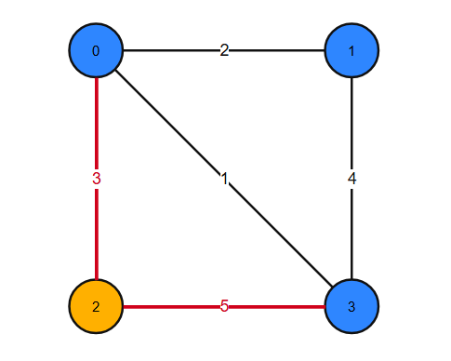
Figure 2 -Previous example
S = {0, 1, 3} (blue) T = {2} (orange)
Crossing edges: (0,2) w=3, (2,3) w=5 ⇒ Cut weight = 8

The brute force algorithm repeats this for all masks and picks the minimum cut weight.
Citations: [3].

4.1.6 Time and Space Complexity
Time complexity:
There are $2^{\left(n-1\right)}$ assignments for vertices $1..n-1$. We skip one invalid assignment (mask = 0), but this does not change asymptotic complexity. For each assignment, we compute the cut weight by scanning all m edges, which costs $O\left(m\right)$ time.
Therefore total time is:
- $O\left(2^{\left(n-1\right)}*m\right) = O\left(2^{n}*m\right)$.
Space complexity:
- Storing the graph: $O\left(n+m\right)$ (adjacency list) or $O\left(m\right)$ (edge list).
- Storing partitions: $O\left(n\right)$.
Overall$: O\left(n+m\right)$ space (dominated by graph storage).
Citations: [3]

Iterative Improvement

4.2.1 Core Idea
Iterative improvement (also called local search) is a general technique for optimization problems. The method starts from a feasible solution and repeatedly applies a small modification (a “local move”) that improves the objective value. The algorithm stops when no improving local move can be found; at that point, the solution is a local optimum with respect to the chosen neighborhood structure. This local optimum is not necessarily a global optimum.
Citations: [1], [6], [7].
In our minimum cut problem, a feasible solution is any valid cut (S, T) where neither side is empty. A natural “small change” is to move a single vertex from one side of the cut to the other (i.e., flip its side assignment). This produces a neighboring cut.

4.2.2 Solution Representation
We represent a cut using an array:
- side[v] in {0, 1} for each vertex v
  - side[v] = 0 means vertex v is in set S
  - side[v] = 1 means vertex v is in set T
Given side[], the cut weight is computed as:
$$W=\sum_{\{u,v\}∈E, side\left[u\right]≠side\left[v\right]}{w\left(u,v\right)}$$
This is the same objective as in brute force, but now we attempt to reduce W using local moves instead of enumerating all cuts.
Citations: [3], [6].

4.2.3 Neighborhood Structure (Local Move)
Neighborhood definition: A neighboring solution is obtained by selecting one vertex v and flipping it:
- side[v] = 1 - side[v]
Validity constraint: The cut must remain nontrivial, i.e., both sides must stay nonempty after the flip. Therefore, we reject any flip that would make all vertices belong to S or all vertices belong to T. (In implementation, we track countS and countT to enforce this.)
Citations: [6], [7].

4.2.4 Delta (Change in Cut Weight) for Flipping One Vertex
To perform local improvement efficiently, we need to compute how the cut weight changes if we flip a vertex v.
Let Delta(v) be the change in cut weight when v is flipped:
- New weight W_new = W + Delta(v)
For each neighbor u of v:
- If u is currently on the same side as v, then edge (v,u) is currently NOT crossing; after flipping v, it WILL cross, increasing the cut by +w(v,u).
- If u is currently on a different side than v, then edge (v,u) is currently crossing; after flipping v, it will become internal, decreasing the cut by -w(v,u).
So:
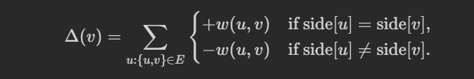
A flip is improving if it decreases the cut weight, i.e., if:
[Equation]
$$Δ\left(v\right)<0$$
This delta-based computation is a standard local search technique: evaluate the objective change of a local move without recomputing the full objective from scratch.
Citations: [6], [7].

4.2.5 Best-Improvement Strategy (Steepest Descent)
In each iteration, there may be many vertices whose flip reduces the cut weight. We use the best-improvement strategy (also called steepest descent):
- Compute $Δ\left(v\right)$ for every vertex v (that can be flipped without violating nonempty sides).
- Select the vertex v* with the smallest delta (most negative).
- If $Δ\left(v*\right)$< 0, flip v* and update the current solution.
- Otherwise, stop (local optimum reached).
Best-improvement tends to use fewer iterations than first-improvement, but each iteration does more work because it evaluates all possible moves.
Citations: [6], [7].

4.2.6 Multi-Start Strategy (to reduce local optimum risk)
A single local search run can get stuck in a poor local minimum depending on the starting cut. To improve solution quality, we use multi-start local search:
- Repeat local search from R different random initial cuts.
- Return the best cut found among all runs.
This is a standard way to mitigate local optima issues in heuristic optimization.
Citations: [6], [7].

4.2.7 Step-by-Step Methodology (Iterative Improvement + Multi-Start)
For a chosen number of restarts R:
For each restart r = 1..R:
- Generate a random initial valid cut side[] (ensure both sides nonempty).
- Compute the initial cut weight W.
- Repeat:
  - For each vertex v, compute $Δ\left(v\right)$ (skip invalid flips that empty a side).
  - Choose the best improving vertex v* with minimum delta.
  - If $Δ\left(v*\right)$ < 0, flip v* and update W.
  - Else stop.
- Save the final solution of this restart.
- Keep the best solution across all restarts.
Output: the best cut found, its weight, and diagnostic statistics such as number of iterations per restart and total restarts.
Citations: [6], [7].

4.2.8 Iterative Improvement Pseudocode
Algorithm 2: LocalImprovementMinCut(G, R)
- Input: weighted undirected graph with n vertices and adjacency list adj, number of restarts R
- Output: best cut found (approximate) and its weight

- LocalImprovementMinCut(n, adj, R, seed):
- rng = Random(seed)
- bestWeight = +infinity
- bestSide[0..n-1] = all 0

- for restart from 1 to R:
- side = RandomInitialCut(n, rng) // ensure both sides nonempty
- countS = number of vertices with side[v] = 0
- countT = n - countS

- W = CutWeight(side, edges) // compute initial weight O(m)

- improved = true
- while improved:
- improved = false
- bestDelta = 0
- bestV = -1

- for v from 0 to n-1:
- // Do not allow flips that make one side empty
- if side[v] == 0 and countS == 1: continue
- if side[v] == 1 and countT == 1: continue

- delta = 0
- for each (u, w_uv) in adj[v]:
- if side[u] == side[v]:
- delta = delta + w_uv
- else:
- delta = delta - w_uv

- if delta < bestDelta:
- bestDelta = delta
- bestV = v

- if bestV != -1: // we found an improving move
- // apply the flip
- if side[bestV] == 0: countS--; countT++
- else: countT--; countS++
- side[bestV] = 1 - side[bestV]
- W = W + bestDelta
- improved = true

- if W < bestWeight:
- bestWeight = W
- bestSide = side

- return bestWeight, PartitionFrom(bestSide)

4.2.9 Worked Example
We use the same 4-vertex graph from Section 4.1:
Edges:
- (0,1,2)
- (0,2,3)
- (0,3,1)
- (1,3,4)
- (2,3,5)
Suppose we start with the random cut:
- S = {0,2}
- T = {1,3}
Compute crossing edges:
- (0,1) crosses: +2
- (0,3) crosses: +1
- (2,3) crosses: +5 Total W = 8.
Now consider flipping vertex 2 from S to T.
- Before flip, 2 is in S; after flip, 2 moves to T.
Edges incident to 2:
- (0,2,3): currently crossing (0 in S, 2 in S? actually 0 in S, 2 in S -> internal), after flip it becomes crossing -> +3
- (2,3,5): currently crossing (2 in S, 3 in T), after flip becomes internal -> -5
So Delta(2) = +3 - 5 = -2, which is improving. New weight: W_new = 8 + (-2) = 6.
After the flip:
- S = {0}
- T = {1,2,3} New crossing edges:
- (0,1) +2
- (0,2) +3
- (0,3) +1 Total = 6.
If no further single-vertex flip reduces the cut weight, local search stops here, returning cut weight 6.
This illustrates how local improvement can reduce the cut weight step-by-step, but it may stop at a local optimum depending on the neighborhood definition and initial cut.
Citations: [6], [7].

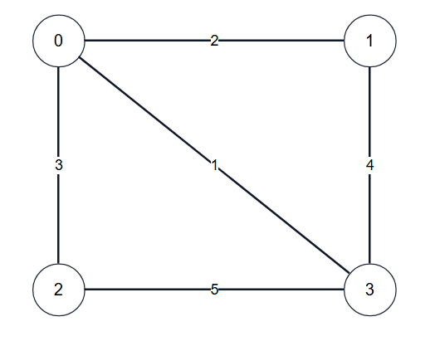
Figure 3 - Weighted Graph for this example

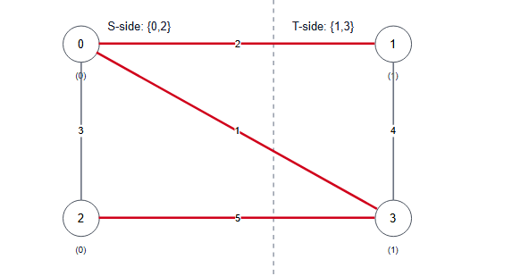
Figure 4 - Initial partition and its cut weight computed from crossing edges.
Crossing edges (X):
(0,1)=2
(0,3)=1
(2,3)=5
Cut weight W = 2 + 1 + 5 = 8
Non-crossing edges (·):
(0,2)=3
(1,3)=4

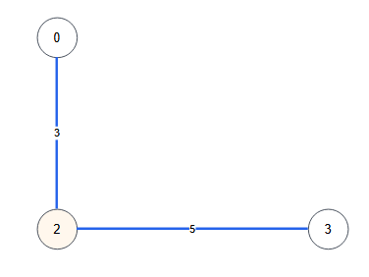
Figure 5 - Delta calculation for flipping one vertex using only incident edges.

Before flip: side[2] = S
After flip: side[2] = T
(0,2) = 3
Before: 0 in S and 2 in S ⇒ NOT crossing
After : 0 in S and 2 in T ⇒ crossing
Contribution to Δ(2): +3
(2,3) = 5
Before: 2 in S and 3 in T ⇒ crossing
After : 2 in T and 3 in T ⇒ NOT crossing
Contribution to Δ(2): -5
Δ(2) = +3 + (-5) = -2
W_{new} = W + Δ(2) = 8 + (-2) = 6
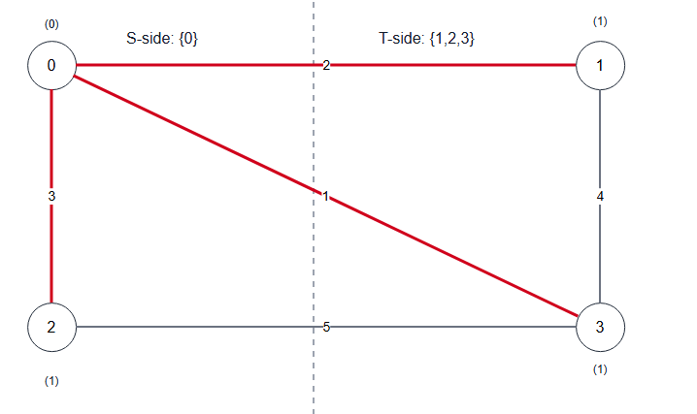
Figure 6 -Partition after one improving move, resulting in a smaller cut weight.
Crossing edges (X):
(0,1)=2
(0,2)=3
(0,3)=1
Cut weight W = 2 + 3 + 1 = 6
Non-crossing edges (·):
(1,3)=4
(2,3)=5

4.2.11 Notes on Limitations (Local Optimum vs Global Optimum)
Iterative improvement with single-vertex flips guarantees that the cut weight decreases in each improving step, so it must eventually terminate. However, termination only guarantees a solution that is locally optimal with respect to the chosen neighborhood (single-vertex flips). A better cut may exist that requires moving multiple vertices simultaneously, which single-vertex local search cannot reach without allowing non-improving moves or restarts.
Citations: [6], [7].

4.2.12 Time and Space Complexity
Time Complexity
In one local-search iteration, the algorithm considers flipping each vertex v (as long as flipping does not make one side empty). For each candidate vertex v, it computes Delta(v) by scanning all neighbors of v, which costs $O(deg(v))$.
When this is done for all vertices in the same iteration, the total work is:
- sum of deg(v) over all vertices = 2m in an undirected graph
So, the time per iteration is:
- $O(m)$
Citations: [3], [6], [7].
Let I be the number of improving flips (iterations) performed until the algorithm stops (reaches a local optimum) in one restart. Then the runtime for one restart is:
- $O(I * m)$
If we run the algorithm for R restarts (multi-start), the total time becomes:
- $O(R * I_avg * m)$
where I_avg is the average number of iterations per restart.
Citations: [6], [7].
Space Complexity
The algorithm stores:
- the graph (adjacency list and/or edge list): $O(n + m)$
- the current cut assignment side[]: $O(n)$
- a few counters and variables: $O(1)$
Therefore, the total space complexity is:
- $O(n + m)$
Citations: [3].

Implementation Details

4.3.1 Implementation Overview
This section describes how the two required techniques are implemented in C++:
- Brute Force (Exact): Enumerates all cuts by iterating over bitmasks representing membership of vertices in set T (with vertex 0 fixed in S to avoid duplicate cuts). For each mask, the cut weight is computed by scanning all edges.
- Iterative Improvement (Approximate): Uses multi-start local search. Each restart begins with a random valid cut, then repeatedly applies the best-improving single-vertex flip until no improvement exists. The best final cut across all restarts is returned.
This design follows standard local-search methodology and directly reflects the iterative improvement paradigm: start from a feasible solution, improve locally, and stop when no local improvement can be found.
Citations: [1], [6], [7].

4.3.2 Data Structures
To support both algorithms efficiently and clearly, we store the graph in two forms:
- Edge list edges for brute force cut weight evaluation:
  - Edge { int u, v; long long w; }
- Adjacency list adj for local improvement delta computations:
  - adj[v] contains pairs (neighbor, weight)
We use long long for weights and cut sums to reduce overflow risk when weights are integers and sums become large.
Note: If the input contains duplicate edges (u, v) multiple times, the implementation can either:
- accept them as parallel edges (still valid; they simply add to the cut weight), or
- optionally merge them by summing weights (not required for correctness).
For simplicity and correctness, we accept parallel edges as-is; this matches the mathematical model where each edge contributes to the cut weight independently.
Citations: Basic graph representations are standard. [3].

4.3.3 Helper Functions (High-Level Description)
The implementation is organized around these helper operations:
- computeCutWeight(side)
Returns total cut weight given side[v] in {0,1}.
- partitionFromSide(side)
Builds explicit vertex lists S and T for printing.
- randomInitialCut(n, rng)
Generates a random cut with both sides nonempty.
- localImproveOnce(side)
Runs the best-improvement loop until a local optimum is reached; returns the final weight and side array.
- multiStartLocalSearch(R)
Runs R restarts and keeps the best result.
This modular structure improves clarity and helps satisfy the report requirement for step-by-step methodology.
Citations: [7] (implementation-oriented metaheuristics practices), [6].

4.3.4 C++ Implementation Code
#include <bits/stdc++.h>
using namespace std;

struct Edge {
int u, v;
long long w;
};

struct Result {
long long weight = (1LL<<62);
vector<int> side; // 0 => S, 1 => T
long long iterations = 0; // local search iterations (moves)
int restarts = 0;
};

static long long computeCutWeight(const vector<int>& side, const vector<Edge>& edges) {
long long W = 0;
for (const auto& e : edges) {
if (side[e.u] != side[e.v]) W += e.w;
}
return W;
}

static pair<vector<int>, vector<int>> partitionFromSide(const vector<int>& side) {
vector<int> S, T;
for (int v = 0; v < (int)side.size(); v++) {
if (side[v] == 0) S.push_back(v);
else T.push_back(v);
}
return {S, T};
}

static vector<int> randomInitialCut(int n, mt19937_64& rng) {
// Ensure both sides are nonempty.
// Simple approach: assign random sides, then fix if all ended up same.
vector<int> side(n, 0);
uniform_int_distribution<int> bit(0, 1);

while (true) {
int countT = 0;
for (int v = 0; v < n; v++) {
side[v] = bit(rng);
countT += side[v];
}
if (countT != 0 && countT != n) break;
}
return side;
}

static Result localImproveBestFlip(
const vector<vector<pair<int,long long>>>& adj,
const vector<Edge>& edges,
vector<int> sideInit
) {
int n = (int)sideInit.size();
vector<int> side = std::move(sideInit);

int countT = 0;
for (int v = 0; v < n; v++) countT += side[v];
int countS = n - countT;

long long W = computeCutWeight(side, edges);

long long iterations = 0;

while (true) {
long long bestDelta = 0; // we need delta < 0 to improve
int bestV = -1;

for (int v = 0; v < n; v++) {
// enforce nonempty sides after flip
if (side[v] == 0 && countS == 1) continue; // would empty S
if (side[v] == 1 && countT == 1) continue; // would empty T

long long delta = 0;
for (auto [u, w_uv] : adj[v]) {
if (side[u] == side[v]) delta += w_uv;
else delta -= w_uv;
}

if (delta < bestDelta) {
bestDelta = delta;
bestV = v;
}
}

if (bestV == -1) break; // no improving move

// apply the best move
if (side[bestV] == 0) { countS--; countT++; }
else { countT--; countS++; }

side[bestV] = 1 - side[bestV];
W += bestDelta;
iterations++;
}

Result res;
res.weight = W;
res.side = std::move(side);
res.iterations = iterations;
return res;
}

static Result multiStartLocalImprovement(
const vector<vector<pair<int,long long>>>& adj,
const vector<Edge>& edges,
int R,
unsigned long long seed
) {
int n = (int)adj.size();
mt19937_64 rng(seed);

Result best;
best.weight = (1LL<<62);
best.restarts = R;

for (int r = 1; r <= R; r++) {
vector<int> init = randomInitialCut(n, rng);
Result cur = localImproveBestFlip(adj, edges, init);
if (cur.weight < best.weight) best = cur;
best.iterations += cur.iterations; // total iterations across restarts (for reporting)
}
return best;
}

static Result bruteForceMinCut(int n, const vector<Edge>& edges) {
// Brute force enumerates subsets of vertices 1..n-1.
// side[0]=0 is fixed in S.
// side[v]=1 means vertex v is in T.
Result best;
best.weight = (1LL<<62);
best.side.assign(n, 0);

if (n <= 1) {
// No valid nontrivial cut exists; keep default.
best.weight = 0;
return best;
}

long long totalMasks = 1LL << (n - 1); // works for n-1 <= 62; brute force is anyway small-n
vector<int> side(n, 0);
side[0] = 0;

for (long long mask = 0; mask < totalMasks; mask++) {
if (mask == 0) continue; // would make T empty

for (int v = 1; v < n; v++) {
side[v] = (int)((mask >> (v - 1)) & 1LL);
}

long long W = computeCutWeight(side, edges);
if (W < best.weight) {
best.weight = W;
best.side = side;
}
}
return best;
}

int main() {
ios::sync_with_stdio(false);
cin.tie(nullptr);

int n, m;
cin >> n >> m;

vector<Edge> edges;
edges.reserve(m);

vector<vector<pair<int,long long>>> adj(n);

for (int i = 0; i < m; i++) {
int u, v;
long long w;
cin >> u >> v >> w;
edges.push_back({u, v, w});
adj[u].push_back({v, w});
adj[v].push_back({u, w});
}

// Parameters (can be adjusted for experiments)
int R = 50; // number of restarts for local improvement
unsigned long long seed = 123456789ULL;

// Run approximate method
Result approx = multiStartLocalImprovement(adj, edges, R, seed);

cout << "=== Iterative Improvement (Approx) ===\n";
cout << "Best cut weight = " << approx.weight << "\n";
auto [S1, T1] = partitionFromSide(approx.side);
cout << "S: ";
for (int v : S1) cout << v << " ";
cout << "\nT: ";
for (int v : T1) cout << v << " ";
cout << "\nTotal local moves (across restarts) = " << approx.iterations << "\n";
cout << "Restarts = " << approx.restarts << "\n\n";

// Run exact brute force only for small n
if (n <= 25) {
Result exact = bruteForceMinCut(n, edges);
cout << "=== Brute Force (Exact) ===\n";
cout << "Minimum cut weight = " << exact.weight << "\n";
auto [S2, T2] = partitionFromSide(exact.side);
cout << "S: ";
for (int v : S2) cout << v << " ";
cout << "\nT: ";
for (int v : T2) cout << v << " ";
cout << "\n";
} else {
cout << "=== Brute Force (Exact) ===\n";
cout << "Skipped (n too large for brute force enumeration).\n";
}

return 0;
}

4.3.5 Notes on Correctness and Practical Considerations
- Correctness of brute force: It checks all valid cuts (with vertex 0 fixed to remove symmetry), so it always finds the global minimum cut for small enough n.
Citations: [3].
- Correctness of iterative improvement termination: The local search accepts only strictly improving moves (Delta < 0), so the cut weight decreases each iteration. Since there are finitely many cuts, the algorithm must terminate. The final cut is a local minimum with respect to single-vertex flips, not necessarily the global minimum.
Citations: [6], [7].
- Randomness and reproducibility: Using a fixed seed produces reproducible runs. Changing the seed can yield different solutions; multi-start improves the chance of finding a near-optimal cut.
Citations: [6], [7].

Comparative Evaluation

6.1 Evaluation Criteria (Metrics)

6.2.1 Solution Quality
For a given graph:
- Let W_opt be the minimum cut weight found by brute force (exact).
- Let W_approx be the cut weight found by iterative improvement (approx).
We compare:
- Absolute gap: W_approx - W_opt
- Approximation ratio (empirical): W_approx / W_opt (only when W_opt > 0)
A ratio of 1.0 means the heuristic matched the exact optimum on that instance.
Citations: [7].

6.2.2 Computational Cost
We compare:
- Whether brute force is feasible (it grows exponentially with n)
- Number of local search moves (iterations) and restarts
- Runtime (optional but recommended if you can measure it consistently)
Because brute force has exponential time complexity, it is expected to become impractical even for moderate n, while iterative improvement should remain usable for much larger graphs.
Citations: [3], [6], [7].

6.2 Experimental Setup

6.2.1 Test Case Categories
To make the evaluation meaningful , we use multiple categories of graphs:
- Small graphs (n <= 25):
Brute force is run, so we can directly compare W_approx against W_opt.
- Larger graphs (n > 25):
Brute force is skipped. We evaluate the heuristic using:
  - best weight found across restarts
  - variability across different runs (optional: different seeds)
  - runtime / iteration counts
Citations: [7].

6.2.2 Parameters Used
The iterative improvement algorithm depends on:
- R: number of restarts
- seed: random seed
In the provided implementation, R is set to 50 and a fixed seed is used for reproducibility. (For deeper evaluation, R can be varied such as 10, 50, 100 to show the trade-off between runtime and quality.)
Citations: [6], [7].

6.3 Comparative Results on Sample Graphs (Exact vs Approx)
This subsection reports the results you obtained from three representative test cases. These examples demonstrate both correctness (weights match the computed cut) and how the heuristic compares to the exact optimum on small graphs.
Table 1. Comparison of iterative improvement vs brute force on sample inputs.
Case | n | m | W_approx | W_opt | Gap (W_approx-W_opt) | Ratio (W_approx/W_opt)
1 | 4 | 5 | 6 | 6 | 0 | 1.00
2 | 2 | 1 | 7 | 7 | 0 | 1.00
3 | 6 | 7 | 1 | 1 | 0 | 1.00

Discussion:
- In all three sample cases, the iterative improvement method found a cut with the same weight as the brute-force optimum (ratio = 1.00).
- Note that the partition returned by the heuristic may differ from the exact solver even when the weights match, because minimum cuts are not always unique.
Citations: [3] (non-uniqueness of optimal solutions in optimization problems), [6], [7].

6.4 Interpretation and Scalability Discussion

6.4.1 When Brute Force is Useful
Brute force is valuable as:
- an exact solver for very small graphs,
- a verification tool to confirm correctness of the heuristic implementation,
- a baseline for measuring the heuristic’s empirical approximation quality.
However, due to exponential growth in the number of cuts, brute force becomes impractical as n increases.
Citations: [3].

6.4.2 Why Iterative Improvement Scales Better
Iterative improvement evaluates local changes and usually converges in a relatively small number of iterations compared to enumerating all cuts. With multi-start, it often produces near-optimal cuts in practice, but it has no guarantee to always find the global minimum cut.
Citations: [6], [7].

Alternative Approaches / More Efficient Techniques

7.1 Exact Global Minimum Cut in Undirected Graphs (Stoer–Wagner)
For undirected weighted graphs, the Stoer–Wagner algorithm finds the global minimum cut exactly in polynomial time. This is important because it shows that, under the assumptions used in this report (undirected graph, global min cut), there exists an exact method that is dramatically faster than brute force enumeration and does not suffer from local optimum issues like iterative improvement.
In practice, Stoer-Wagner repeatedly performs a “minimum cut phase” that grows a set of vertices using maximum adjacency weights, producing a cut candidate at the end of each phase and then contracting vertices to reduce the problem size. The minimum over all phases is the global minimum cut. While the internal details are not implemented in this project, the main takeaway is that it provides an exact solution with much better scalability than brute force.
Citations: [4], [3].

7.2 Exact s–t Minimum Cut via Maximum Flow (Max-Flow Min-Cut)
If a problem instance specifies two special vertices s (source) and t (sink), then the task becomes the s–t minimum cut problem. In that case, the minimum cut can be solved exactly by computing a maximum flow, due to the max-flow min-cut theorem. This approach is widely used in network design, routing, and many optimization applications.
Several polynomial-time max-flow algorithms exist (e.g., Edmonds–Karp, Dinic, and push–relabel). Their performance depends on the graph size and density, but they are typically efficient on large inputs compared to brute force. In this project, we did not implement max-flow because the task statement does not provide s and t and because the required techniques were brute force and iterative improvement. Nevertheless, max-flow is an important alternative to mention because it is a standard exact method for cut problems when the cut is defined with respect to specific terminals.
Citations: [3], [5].

7.3 Randomized Algorithms for Min Cut (Alternative Exact/Probabilistic Perspective)
Another direction is randomized algorithms. For undirected graphs, contraction-based randomized algorithms can find a global minimum cut with some probability, and repeating the algorithm increases the success probability. These methods can be attractive when:
- a fast algorithm is needed,
- some probability of failure is acceptable, or
- the algorithm is repeated enough times to make failure extremely unlikely.
This perspective is different from local improvement: instead of improving a single solution, randomized methods sample the solution space through random contractions. (This project does not implement randomized min cut, but it is a relevant alternative approach.)
Citations: [3] (randomization as a general algorithmic tool; min-cut randomized methods are commonly covered in advanced algorithm topics).

7.4 Stronger Heuristics than Basic Local Improvement (Escaping Local Minima)
The iterative improvement implemented in this project uses strict descent (only accept moves that reduce the cut weight). A known limitation of strict descent local search is that it can become trapped in a poor local optimum. Multi-start partially mitigates this, but other heuristic frameworks can further improve solution quality:
- Simulated annealing: occasionally accepts worse moves early to escape local minima, then becomes more selective later.
- Tabu search: uses short-term memory (tabu list) to avoid cycling and to encourage exploration.
- Genetic algorithms: maintain a population of cuts and combine them to create new candidate solutions.
These techniques typically require parameter tuning and more complex implementation, but they can outperform basic local improvement on difficult instances where local minima are common.
Citations: [6], [7].

Sample Inputs/Outputs
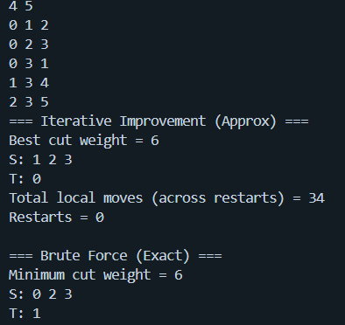
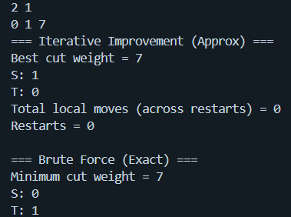
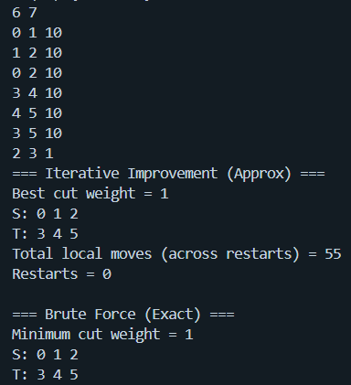

References
[1] Anany Levitin, Introduction to the Design and Analysis of Algorithms, 3rd ed., Pearson.
[2] Amrinder Arora, Analysis and Design of Algorithms, 2nd ed.
[3] T. H. Cormen, C. E. Leiserson, R. L. Rivest, and C. Stein, Introduction to Algorithms, 4th ed., MIT Press.
[4] M. Stoer and F. Wagner, “A Simple Min-Cut Algorithm,” Journal of the ACM, 44(4), 1997.
[5] R. K. Ahuja, T. L. Magnanti, and J. B. Orlin, Network Flows: Theory, Algorithms, and Applications, 1993.
[6] E. Aarts and J. K. Lenstra (eds.), Local Search in Combinatorial Optimization, Princeton University Press, 2003.
[7] E.-G. Talbi, Metaheuristics: From Design to Implementation, Wiley, 2009.

